Specific Facilities Provided For Women
Safety and Security:
- Extensive surveillance network with 24x7 monitored control rooms.
- Rotational duty by all faculty members for discipline and security.
- The Proctorial Committee includes male and female proctors at institute as well as faculty level
- Strict implementation of Anti-Ragging on Campus.
- Awareness campaigns on women safety and gender sensitivity through self-defense workshop
- The Institute is the preferred destination of parents for education of their female -wards.
- Eco-friendly crèche for wards of institute staff with dedicated staff supervisors.
- Formal and informal avenues for counseling male and female students and staff for academic and other issues/problems.
- Class and Proctorial Committees are available for counseling of both males and female students.
- Grievance Redressal Committees for staff and students
- There is Sexual Harassment Cell which takes up the complaints of girls and provides timely and speedy redressal to them to the satisfaction of the complainant. Women Cell also offers apt resolutions to the complaints of girls.
- The college students regularly take pledge and tie Sankalp Sutras with the promise not to indulge in social evils like eve teasing and female feticide and pledge to voice their opinions against them fearlessly

CCTV cameras are strategically installed at sensitive places which keep a check on any untoward incidents.
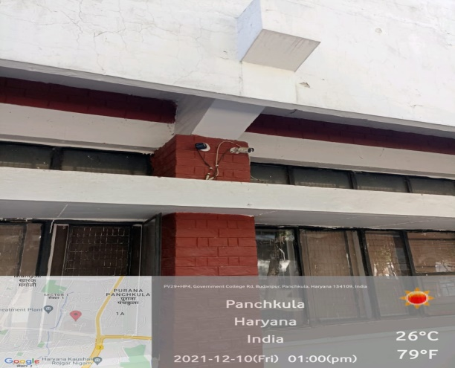
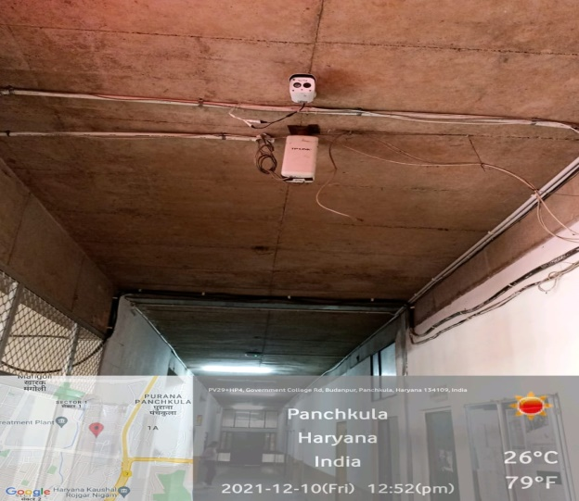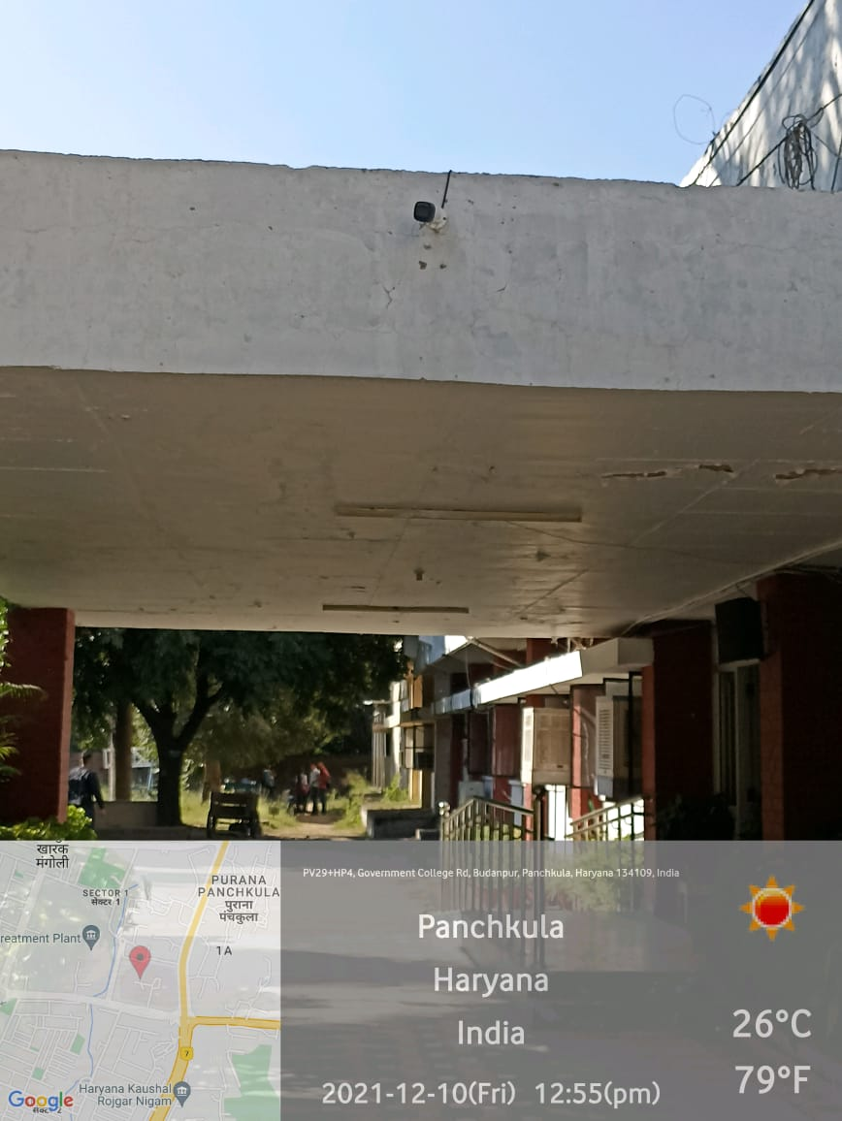
CCTV Camera in all areas of campus

Counselling Cell
The college has constituted a Counseling Cell in the Department of Psychology with the main objective to resolve the anxiety and stress amongst young students. As the majority of faculty in the department are female, it is convenient for the girl students to discuss their problems with them. Each student has been allotted a mentor with whom they can discuss their problems freely. The YourDost app was launched by the Department of Higher Education which provides online counselling of students while maintaining their anonymity.
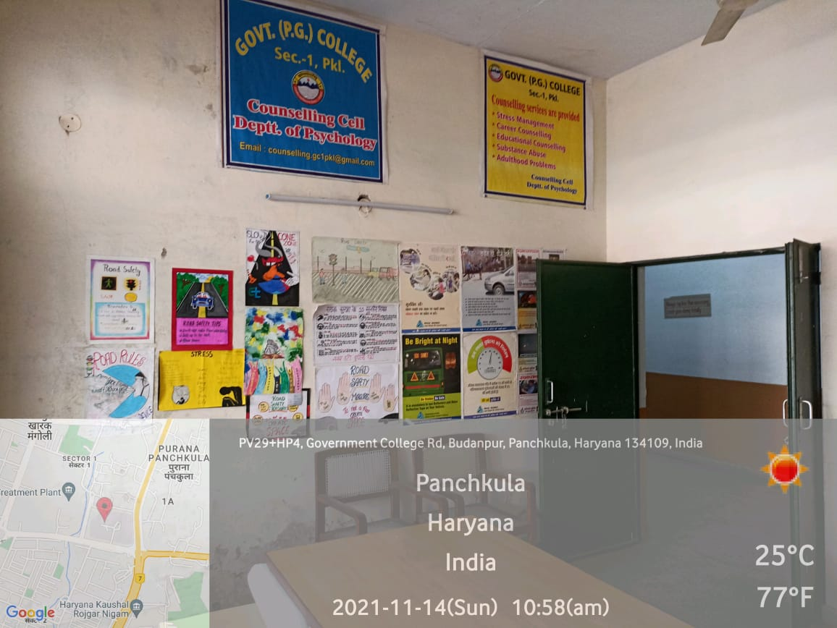

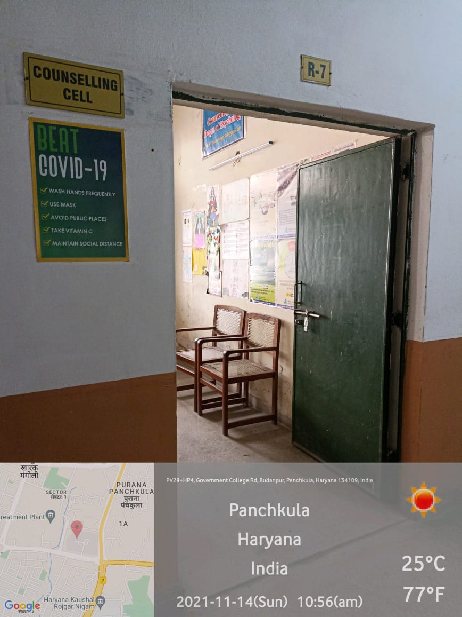
Common Room:
A spacious makeshift Common room with washrooms having sanitary-pad vending machine and incinerators has been provided to the girls to ensure free, healthy and hygienic surrounding for the girls.

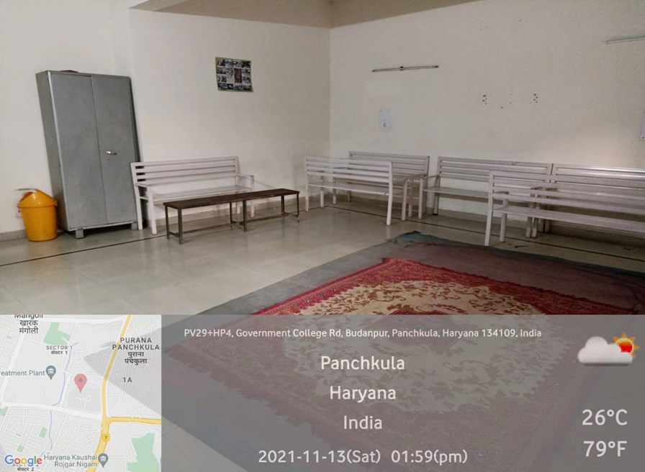

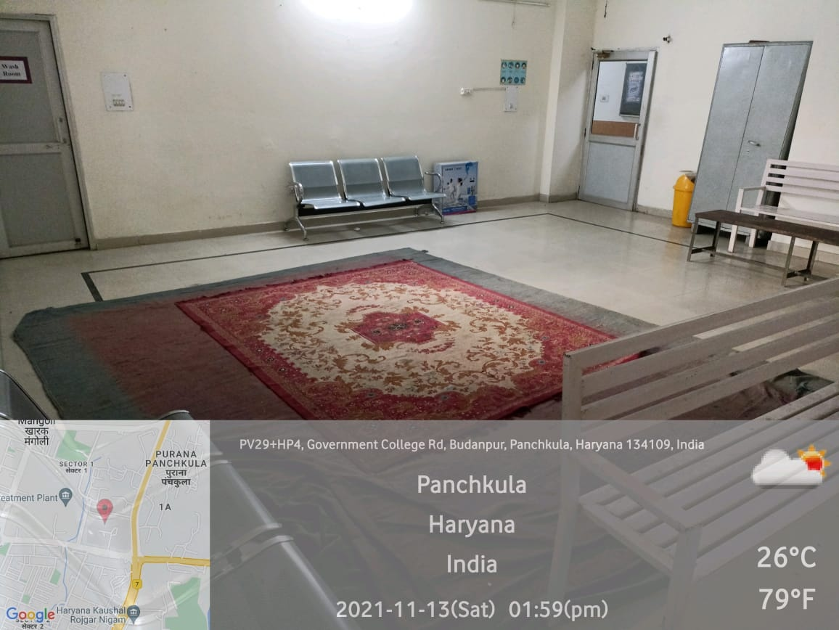
Day Care Centre:
The Day-care facility has been provided to female staff to make working easy for new mothers and staff with small kids.